**Histogram**

A histogram represents the frequencies of values of a variable bucketed into ranges. Histogram is similar to bar chart but it groups the values into continuous ranges. Each bar in histogram represents the height of the number of values present in that range.

Tableau creates a histogram by taking one measure. It creates an additional bin field for the measure used in creating histogram.

## Creating Histogram

Using the Sample-superstore, let's plan to find the of quantities of sales for different regions.To achieve this objective we follow the below steps. Drag the Measure named Quantity to the Rows shelf. Then open Show Me and select Histogram chart. The below diagram shows the chart created. It shows the quantities automatically bucketed into values ranging from 0 to 4811 and divided into 12 bins.

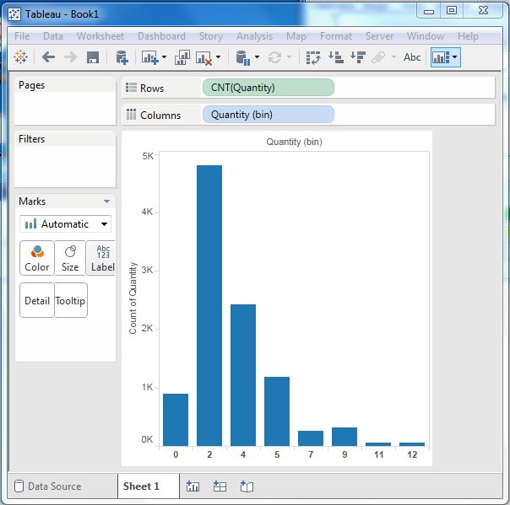

## Creating Histogram with Dimension

We can also add Dimensions to Measures to create histograms. That will create a stacked histogram. Each bar will have stacks representing the values of the dimension. Following the steps of the above example we add the Region Dimension to the color Shelf under Marks Card. That creates the below histogram where each bar also includes the visualization for different regions.

